**9/23/2022 Meeting Notes**

1. Dana Wortman agreed to be an advisor, will be sending her a follow up email to provide her with information about our project, what she can assist us with during the lifetime of this project, and invite her to Critical Design Presentation.

Updates this week

* Amylelia
  + Continuing to work on audio
  + Will write assigned Critical Design Section(s)
* Stefano
  + Will send email to Dana Wortman
  + Worked on the tutorial
  + Was able fix Unity project so that it was a 2019 version, instead of the 2020 which would not work with the HoloLens 1
    1. Found the old MRTK toolkit that worked with 2019 version of Unity
  + Will work on part 3 of the tutorial and testing the code with the HoloLens 1
  + Will write assigned Critical Design Section(s)
* Amber
  + Will make email to send to Dana Wortman
  + Will turn in Conceptual Design Report with Testing report listed as “To be completed” as per Bill Michael’s instructions
  + Will update Timeline/Documents to reflect Critical Design Presentation
  + Assisting Austin with starting Yolo and Unity integration
  + Will create documents for Critical Design Document Sections
  + Will create a powerpoint layout for Critical Design Presentation
  + Will write assigned Critical Design Section(s)
* Austin
  + Working on Yolo and Unity integration using a base Unity project
  + Will write assigned Critical Design Section(s)
* Jack
  + Has finished a lot of the code for the probability algorithm, but needs to be more complex than what was originally planned. The math will remain the same though. Hopes to have it complete soon
  + Will write assigned Critical Design Section(s)

THIS WEEK

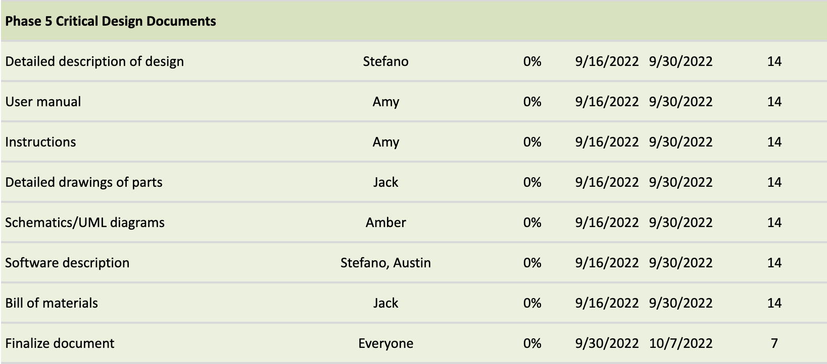

NEXT WEEK

